Existing Holdings
11.30  10 Year Volatility^{[2]} | 6  Balanced Growth^{[4]}

[2]Portfolio future volatility is calculated as the standard deviation of the portfolio's simulated future values over a 10 year term using the portfolio's asset allocation. Simulated future values are based on stochastic simulations carried out with return, volatility and correlation projections for the underlying asset classes from Hymans Robertson.
[4] As a Balanced Growth investor you do not see yourself as a cautious person and have no strong positive or negative associations with the notion of taking risk. If you have experience of investments and a degree of understanding of financial matters then you may be suited to a Balanced Growth approach to investing. You may also be suited to this approach if you make investment decisions reasonably quickly and don’t tend to be particularly anxious about those decisions. As a Balanced Growth investor you can be inclined to look for a combination of investments with differing levels of risk and understand that you may need to take some risk to meet your investment goals.
Investment | Provider | % Invested
True Potential Allianz Balanced Acc (GBP) | True Potential Administration LLP | 12.01
True Potential Goldman Sachs Balanced Acc (GBP) | True Potential Administration LLP | 5.97
True Potential Growth-Aligned Aggressive Acc (GBP) | True Potential Administration LLP | 23.07
True Potential Schroders Balanced Acc (GBP) | True Potential Administration LLP | 5.10
True Potential SEI Aggressive Inc (GBP) | True Potential Administration LLP | 15.55
True Potential TrinityBridge Balanced A Acc Shares (GBP) | True Potential Administration LLP | 16.65
True Potential UBS Aggressive Acc (GBP) | True Potential Administration LLP | 21.65

Asset allocation

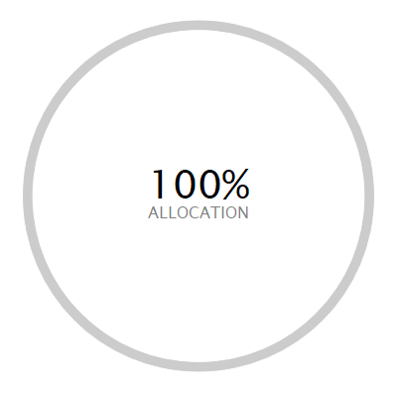 | ASSET ALLOCATION⁽¹⁾ NET %⁽²⁾ SHORT % LONG %  l North America Equity 36.31 -0.11 36.42  l Global (ex-UK) Fixed Income 19.87 -3.21 23.08  l Europe (ex-UK) Equity 15.23 -0.02 15.25  l Japan Equity 6.13 0.00 6.13  l UK Equity 5.91 -0.10 6.01  l UK Government Bonds 5.51 0.00 5.51  l Emerging Markets Equity 5.31 -0.01 5.32  l Cash - Short Term Money Market 4.11 -0.61 4.72  l Developed Pacific (ex-Japan) Equity 3.62 -0.55 4.17  l Commodities 2.96 0.00 2.96  l UK Corporate Bonds 1.74 0.00 1.74  l Absolute Return 0.97 0.00 0.97  l UK Index Linked Bonds 0.07 0.00 0.07  l Private Equity 0.02 0.00 0.02  l Other -7.75 -46.31 38.56
⁽¹⁾ Due to the negative asset allocation within the selected portfolio the investment allocation chart is unavailable.
⁽²⁾ Due to rounding there may be a discrepancy between the Long/Short % and the Net %.

Investment performance
Individual cumulative investment performance graph
The chart shows an investment’s performance, calculated as NAV to NAV/Bid to Bid/Closing Price to Closing Price, with dividends/distributions reinvested, including the effect of ongoing costs and charges. These figures are calculated to the performance date 19 March 2026.
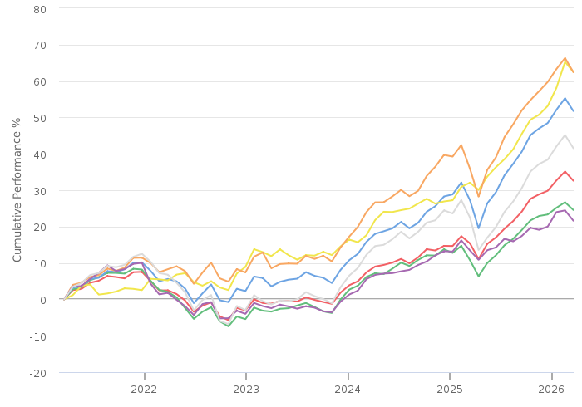
━━ | True Potential Allianz Balanced Acc (GBP) | ━━ | True Potential Goldman Sachs Balanced Acc (GBP)
━━ | True Potential Growth-Aligned Aggressive Acc (GBP) | ━━ | True Potential Schroders Balanced Acc (GBP)
━━ | True Potential SEI Aggressive Inc (GBP) | ━━ | True Potential TrinityBridge Balanced A Acc Shares (GBP)
━━ | True Potential UBS Aggressive Acc (GBP)

Individual cumulative investment performance table
The table shows an investment’s performance, calculated as NAV to NAV/Bid to Bid/Closing Price to Closing Price, with dividends/distributions reinvested, including the effect of ongoing costs and charges.
FUND | Last Performance Update | 3M | 6M | 1YR | 3YR | 5YR | 10YR
True Potential Allianz Balanced Acc (GBP) | 28/02/2026 | 5.99 | 11.95 | 17.70 | 39.47 | 38.77
True Potential Goldman Sachs Balanced Acc (GBP) | 28/02/2026 | 3.98 | 8.86 | 12.73 | 32.77 | 29.67
True Potential Growth-Aligned Aggressive Acc (GBP) | 28/02/2026 | 6.53 | 13.65 | 21.39 | 49.45 | 60.82
True Potential Schroders Balanced Acc (GBP) | 28/02/2026 | 10.98 | 17.86 | 28.73 | 50.15 | 74.49 | 131.32
True Potential SEI Aggressive Inc (GBP) | 28/02/2026 | 6.37 | 12.41 | 21.42 | 49.12 | 77.05 | 180.26
True Potential TrinityBridge Balanced A Acc Shares (GBP) | 28/02/2026 | 4.39 | 8.12 | 9.24 | 28.42 | 26.71 | 77.28
True Potential UBS Aggressive Acc (GBP) | 28/02/2026 | 6.73 | 15.27 | 17.52 | 48.91 | 52.80

Individual discrete investment performance table
The table shows an investments performance, calculated as NAV to NAV/Bid to Bid/Closing Price to Closing Price, with dividends / distributions reinvested, including the effect of ongoing costs and charges. These figures are calculated for calendar years and / or the period within the current year specified.

Existing holdings individual discrete performance data
Fund | 2022 | 2023 | 2024 | 2025 | YTD
True Potential Allianz Balanced Acc | -10.65 | 8.65 | 8.6 | 14.71 | 5.16
True Potential Goldman Sachs Balanced Acc | -13.87 | 10.48 | 7.93 | 11.01 | 3.34
True Potential Growth-Aligned Aggressive Acc | -8.17 | 9.81 | 13.77 | 17.62 | 5.48
True Potential Schroders Balanced Acc | 5.43 | 8.47 | 7.2 | 22.76 | 9.06
True Potential SEI Aggressive Inc | -4.27 | 9.91 | 16.39 | 17.01 | 5.24
True Potential TrinityBridge Balanced A Acc Shares | -13.77 | 7.02 | 9.12 | 7.64 | 4.52
True Potential UBS Aggressive Acc | -15.28 | 12.22 | 13.66 | 13.95 | 5.91

